

[Artificia](https://doi.org/10.1016/j.ailsci.2022.100043)l[IntelligenceintheLifeSciences2(2022)100043](https://doi.org/10.1016/j.ailsci.2022.100043)

|  |  |  |
| --- | --- | --- |
|  | Contentslistsavailableat[ScienceDirect](http://www.ScienceDirect.com) |  |
| ArtificialIntelligenceintheLifeSciences |
| journalhomepage:[www.elsevier.com/locate/ailsci](http://www.elsevier.com/locate/ailsci) |

ResearchArticle

HematoNet:Expertlevelclassificationofbonemarrowcytology morphologyinhematologicalmalignancywithdeeplearning

SatvikTripathia,∗,AlishaIsabelleAugustinb,RithvikSukumaranc,SuhaniDheerd,EdwardKime

a*CollegeofComputingandInformatics,CollegeofArtsandSciences,DrexelUniversity,Philadelphia,USA* b*CollegeofEngineering,DrexelUniversity,Philadelphia,USA*   
c*CollegeofComputingandInformatics,DrexelUniversity,Philadelphia,USA*   
d*CollegeofArtsandSciences,DrexelUniversity,Philadelphia,USA*   
e*CollegeofComputingandInformatics,DrexelUniversity,Philadelphia,PA19104,USA*

|  |  |  |
| --- | --- | --- |
| article | info | abstract |
| *Keywords:*  Deeplearning Bonemarrow Cytology |  | Therehavebeenfeweffortsmadetoautomatethecytomorphologicalcategorizationofbonemarrowcells.For bonemarrowcellcategorization,deep-learningalgorithmshavebeenlimitedtoasmallnumberofsamplesor diseaseclassifications.Inthispaper,weproposedapipelinetoclassifythebonemarrowcellsdespitethese limitations.Dataaugmentationwasusedthroughoutthedatatoresolveanyclassimbalances.Then,random transformationssuchasrotatingbetween0◦to90◦,zoomingin/out,flippinghorizontallyand/orvertically,and translatingwereperformed.ThemodelusedinthepipelinewasaCoAtNetandthatwascomparedwithtwo baselinemodels,EfficientNetV2andResNext50.WethenanalyzedtheCoAtNetmodelusingSmoothGradand Grad-CAM,tworecentlydevelopedalgorithmsthathavebeenshowntomeetthefundamentalrequirementsfor explainabilitymethods.Afterevaluatingallthreemodels’performanceforeachofthedistinctmorphological classes,theproposedCoAtNetmodelwasabletooutperformtheEfficientNetV2andResNext50modelsdueto itsattentionnetworkpropertythatincreasedthelearningcurveforthealgorithmwhichwasrepresentedusing aprecision-recallcurve. |

**1.Introduction**

Thehuman-basedexaminationandcharacterizationofbonemarrow (BM)cellsisoneofthemostimportantyettimeexpensiveprocedures incancerousandnon-canceroushematologicalconditions[1–4]. Thecytomorphologicexaminationisstillacriticalinitialstepinthe diagnosisofmanyintra-andextramedullaryillnesseseventhoughnu-merousadvancedprocedureslikecytogenetics,immunophenotyping, andmoleculargeneticsarenowaccessible[5,6].ThefunctionofBM cytology,whichwascreatedinthe19thcentury,isstillverysignificant becauseofitsrelativelyrapidresultsandextensiveavailability[7,8]. Microscopicinspectionandsingle-cellmorphologycategorizationare stilltheprimaryresponsibilityofhumancliniciansduetothedifficulty inautomatingthisprocess.Incertaincircumstances,suchasthosein-volvingambiguousBMsmears,theprocessofmanuallyevaluatingthe specimensmaybearduousandtime-consuming[9,10].Ithasbeenob-servedthatexaminerclassificationsarepronetosignificantinter-and intravariability,whichmeansthatthenumberofhigh-qualitycytolog-

icalexamsisconstrainedsincesubjectmatterexpertsarehardtocome by[11–15].

Itisalsochallengingtointegratethisprocedurewithotherdiagnostic methodsthatprovidemorequantitativedatasincetheanalysisofindi-vidualcellmorphologiesisqualitativebynature.Feweffortshavebeen madetoautomatethecytomorphologicalcategorizationofBMcells. Hand-craftedsingle-cellcharacteristicsextractedfromdigitalpictures areoftenusedtocategorizecells.Furthermore,mostpriorresearchon automatedcytomorphologicclassificationfocusedontheclassification ofphysiologicalcelltypesorperipheralbloodsmears,restrictingtheir applicabilitytotheclassificationofleukocytesintheBMforthediagno-sisofhematologicalmalignancies[5,16–22].ForBMcellcategorization, deep-learningalgorithmshavebeenlimitedtoasmallnumberofsam-plesordiseaseclassificationsand/orhavenotmadetherelateddata accessible[23–29].

Convolutionalneuralnetworkshavehelpedtosignificantlyincrease theaccuracyofcomputervisionclassificationtasksinthelastfewyears [30–35].Thesemethodshasalsobeenusedtoidentifymultipletypesof

∗Correspondingau[thor.](mailto:st3263@drexel.edu)

*[E-mailaddresse](mailto:ek826@drexel.edu)s:*[st3263@drexel.edu](mailto:st3263@drexel.edu)(S.Tripathi),[aia43@drexel.edu](mailto:aia43@drexel.edu)(A.I.Augustin),[rs3673@drexel.edu](mailto:rs3673@drexel.edu)(R.Sukumaran),[sd3589@drexel.edu](mailto:sd3589@drexel.edu)(S.Dheer), [ek826@drexel.edu](mailto:ek826@drexel.edu)(E[.Kim).](mailto:st3263@drexel.edu)

<https://doi.org/10.1016/j.ailsci.2022.100043>  
[Received22June2022;Receivedinrevisedfo](https://doi.org/10.1016/j.ailsci.2022.100043)rm21July2022;Accepted4August2022   
Availableonline8August2022   
[2667-3185/© 2022TheAuthors.PublishedbyElsevi](http://creativecommons.org/licenses/by-nc-nd/4.0/)erB.V.ThisisanopenaccessarticleundertheCCBY-NC-NDlicense (<http://creativecommons.org/licenses/by-nc-nd/4.0/>)

*S.Tripathi,A.I.Augustin,R.Sukumaranetal.*

cancer,predictprogressionoftumor,andclassifyvarioustypesofskin diseases[36–41].Becauseofthis,theeffectiveuseofCNNsforimage classificationdependsontheavailabilityofasubstantialquantityofim-agedataandhigh-qualityannotation,whichmaybedifficulttoachieve becauseofthecostassociatedincollectinglabelsbymedicalspecial-ists[42–45].Humanexaminersarerequiredtosupplythegroundtruth labelsfornetworktrainingandassessmentininstanceslikecytomor-phologicinspectionofBM,whenthereisnounderlyingtechnological goldstandard.

**2.Relatedwork**

*2.1.Deeplearningapproaches*

DeepLearning(DL)isanareaofmachinelearningthatusesartifi-cialneuralnetworkstomodelthebrain’sstructureandfunction.Deep learningpowersnumerousartificialintelligence(AI)appsandcompa-niesthatautomateanalyticalandphysicalprocesses.Forcancerde-tection,OncologistshavebeenusingDeepLearningmethodstoim-provepatientdiagnosis,prognosis,andtherapyselectionbycombin-inggenomic,transcriptomic,andhistopathologicaldata.Thepurpose ofDListodevelopdecision-makingtoolstoaidcancerresearchers intheirstudiesandhealthprofessionalsintheclinicalcareofcan-cerpatients[46].Inanothercase,Tayebietal.workedonbuilding anend-to-enddeeplearning-basedmodelforautomatedbonemar-rowcytology[47].Acomputerizedfullslidepictureofthepatient’s bloodwasusedtoquicklyandautomaticallydetermineareasappro-priateforcytology,whichwasfollowedbytheidentificationandclas-sificationofallofthebloodcellsinsidethoseareas.Celltypediver-sityinbonemarrowisquantifiedbyusingtheHistogramofCellTypes (HCT),anewvisualdepictionthatservesasacytological“patientfin-gerprint.” Agreatdegreeofprecisionwasachievedinthemethod’sarea detection[48].

*2.2.Hematologicalmalignancy*

Inasimilarresearchconductedonleukemiacancer,thestudycom-paredtwoleukemiadetectionmethods.Thefirstmethodwasagenomic sequencingmethodandthesecondwasmulti-classclassificationmodel. BothemployedaConvolutionalneuralnetwork(CNN)asnetworkde-signandalsousedthree-waycross-validationtoseparatetheirdatasets. Thefindingsindicatedthatthegenomicmodelperformedbetter,with 98percentaccuracyinpredictingvalues,whereastheMulti-classclassi-ficationmodelhasanaccuracyof81percent.Ontheotherhand,another researchlookedattheclinicalusefulnessofanarray-basedgenome-wide screeninleukemia,aswellasthetechnologicalobstaclesandaninter-pretiveprocedure[13].

*2.3.Bonemorrowmorphology*

Anotherstudybyfocusedondevelopinganaccuratebonemarrow cellidentificationtechniqueforquantitativeanalysis.TheYOLOv5net-work[49],trainedbyminimizinganewlossfunction,wasusedinthis studytoofferabonemarrowcellidentificationtechnique.Thesug-gestednewlossfunctionwasbasedonaclassificationalgorithmfor detectingbonemarrowcells.Aspertheresults,theproposedlossfunc-tionwasbeneficialinimprovingthealgorithm’sefficiency,andthepro-posedbonemarrowcellidentificationalgorithmoutperformedother celldetectiontechniques[50].Anotherresearchworkevaluatedhow usefulflowcytometry,karyotype,andafluorescenceinsituhybridiza-tion(FISH)panelareindetectingmyelodysplasticsyndromeinchildren (MDS).ThestudyconcludedthatflowcytometryandMDSFISHmaybe usedinconjunctionwithmorphologicalexaminationandkaryotypeto discoveranomaliesinspecificcases[51].

2

*S.Tripathi,A.I.Augustin,R.Sukumaranetal.*  *ArtificialIntelligenceintheLifeSciences2(2022)100043*

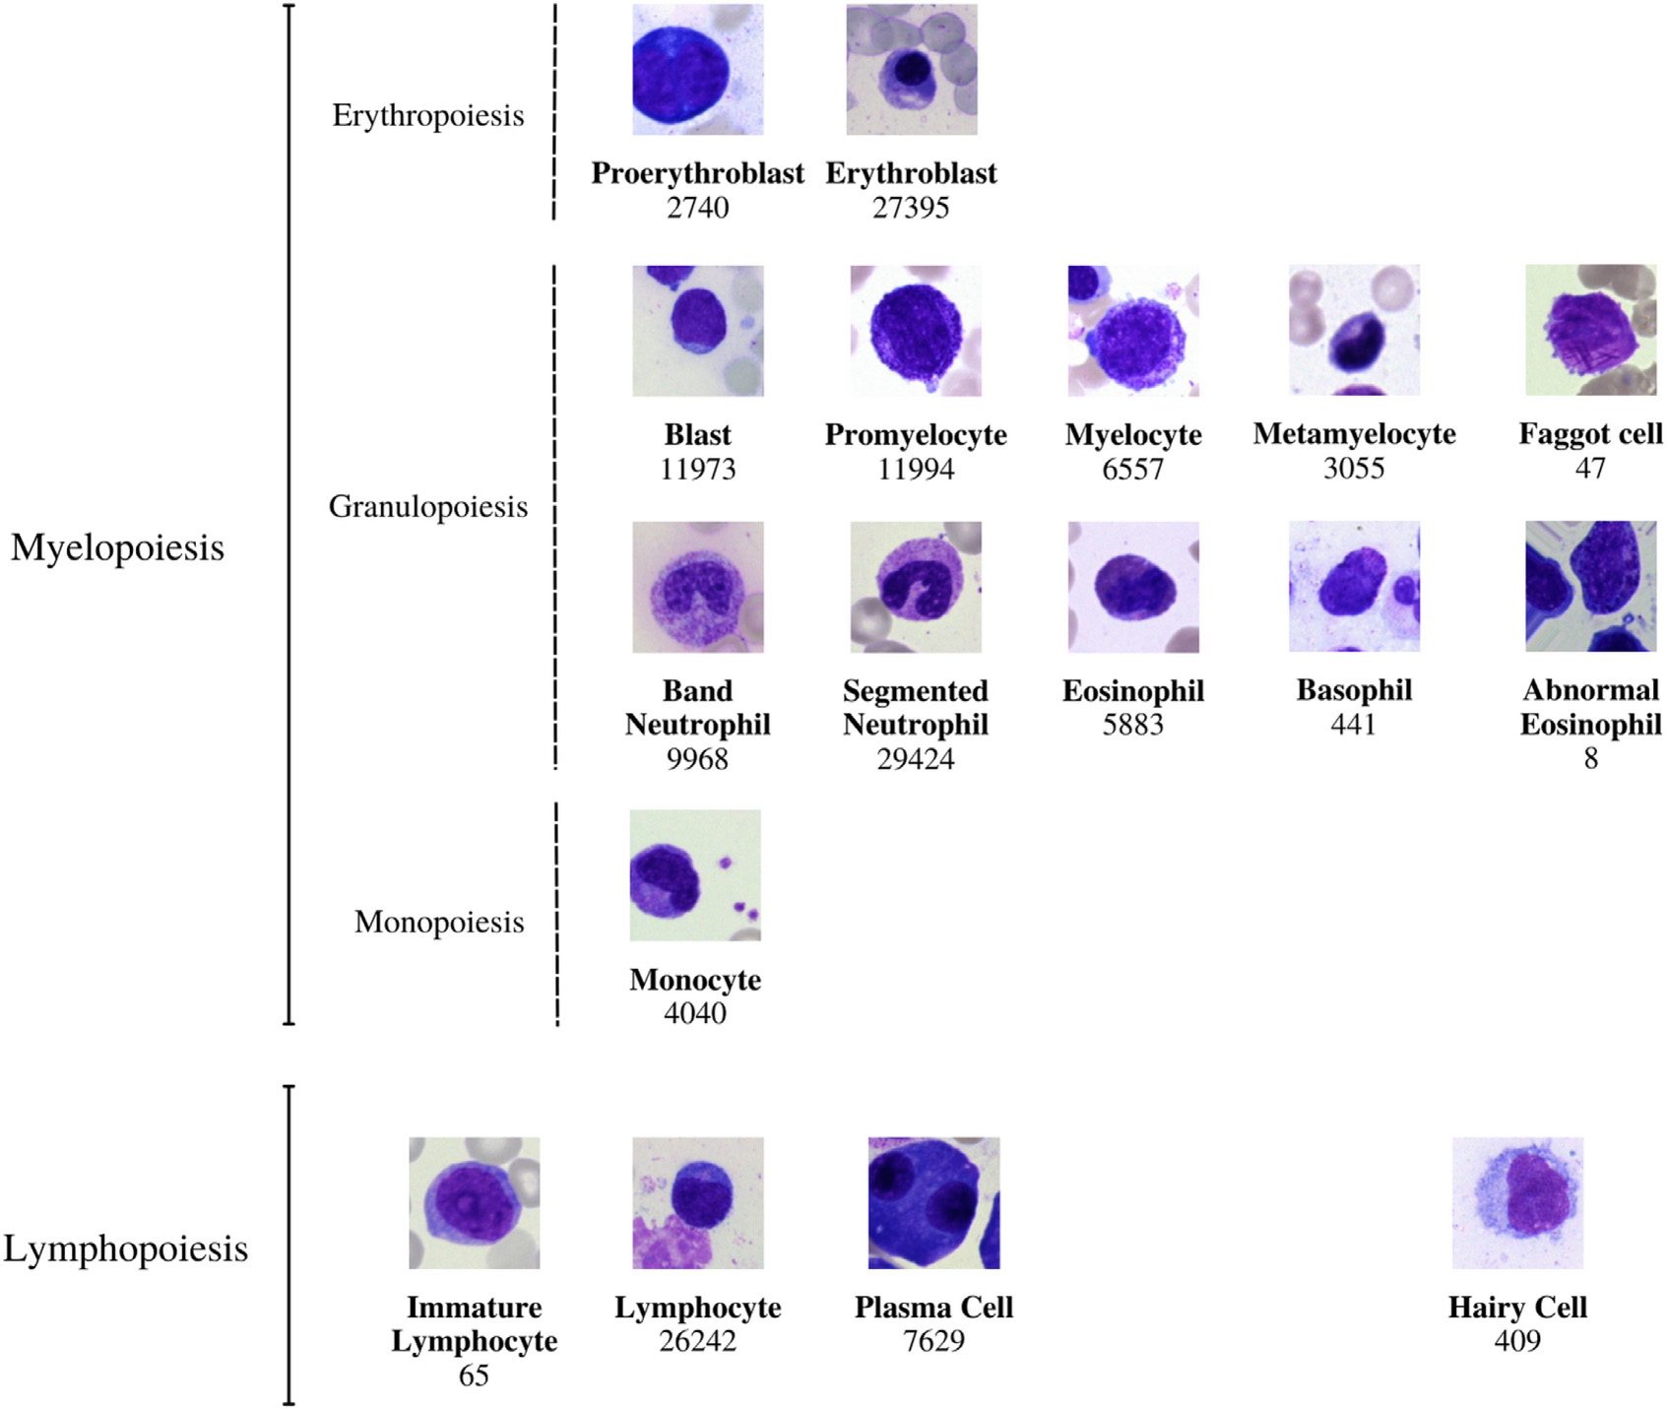

**Fig.1.**The21morphologicalclassificationsofBMcellsemployedinthisinvestigationhaveasimilarstructure.Theclassesarearrangedintohematopoieticlineages inthefollowingorder:Inaccordancewithstandardpractice,themainphysiologicalclassesofmyelopoiesisandlymphopoiesis,aswellastypicalpathologicalclasses and,areallincludedintheclassification.Asdescribedinfurtherdetailinthemaintext,allcellswerestainedwiththeMay-Grunwald-Giemsa/Pappenheimstain andphotographedatamagnificationof340.

Neuronsinartificialneuralnetworksperforminnerproductwhich canbethoughtofasaformofaggregatingtransformation:

∑*𝑤𝑖𝑥𝑖*  (1)

where*𝑥*=[*𝑥*1*,𝑥*2*,...,𝑥𝐷*]isaD-channelinputvectortotheneuronand *𝑤𝑖*isafilter’sweightforthe*𝑖*thchannel.Thisistheelementarytrans-formationthat’sdonebytheconvolutionalandfully-connectedlayers.

Aggregatedtransformationsarepresentedas:

(**𝐱**)=∑*𝑖*(**𝐱**) (2)

where*𝑇𝑖*(*𝑥*)canbeanarbitraryfunction.Analogoustoasimpleneuron, *𝑇𝑖*shouldprojectxintoanembeddingandthentransformit.Thecar-dinalityofthenetwork,*𝐶*,isthesizeofthesetoftransformationsthat willbeaggregatedcanbeanarbitrarynumber.Whilethedimensionof widthisrelatedtothenumberofsimpletransformations,thedimension ofcardinalitycontrolsthenumberofmorecomplextransformations.

**𝐲**=**𝐱**+∑*𝑖*(**𝐱**) (3)

*3.3.2.EfficientNetV2*   
 EfficientNetV2isanewfamilyofconvolutionalnetworkswith quickertrainingspeedsandhigherparametereconomy.Thesemodels aredevelopedusingamixofneuralarchitecturesearchandscaling,

3

*S.Tripathi,A.I.Augustin,R.Sukumaranetal.*

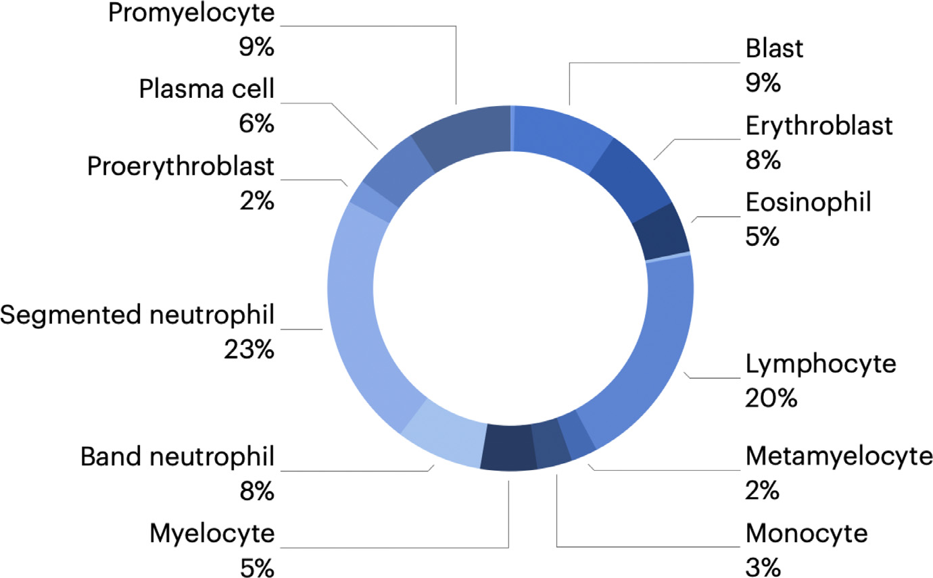

*ArtificialIntelligenceintheLifeSciences2(2022)100043* **Fig.2.**Thepiechartshowsthedatadistribution,we dividedupthe171374nonoverlappingphotosintothe severalclassificationsthatwereutilized.

|  |  |
| --- | --- |
|  | **Fig.3.**Theaugmenteddatafromeachclassesareshowninthefigure. Therandomtransformationsweperformedincludedrotatingbetween 0◦to90◦,zoomingin/out,flippinghorizontallyand/orvertically,and translating. |

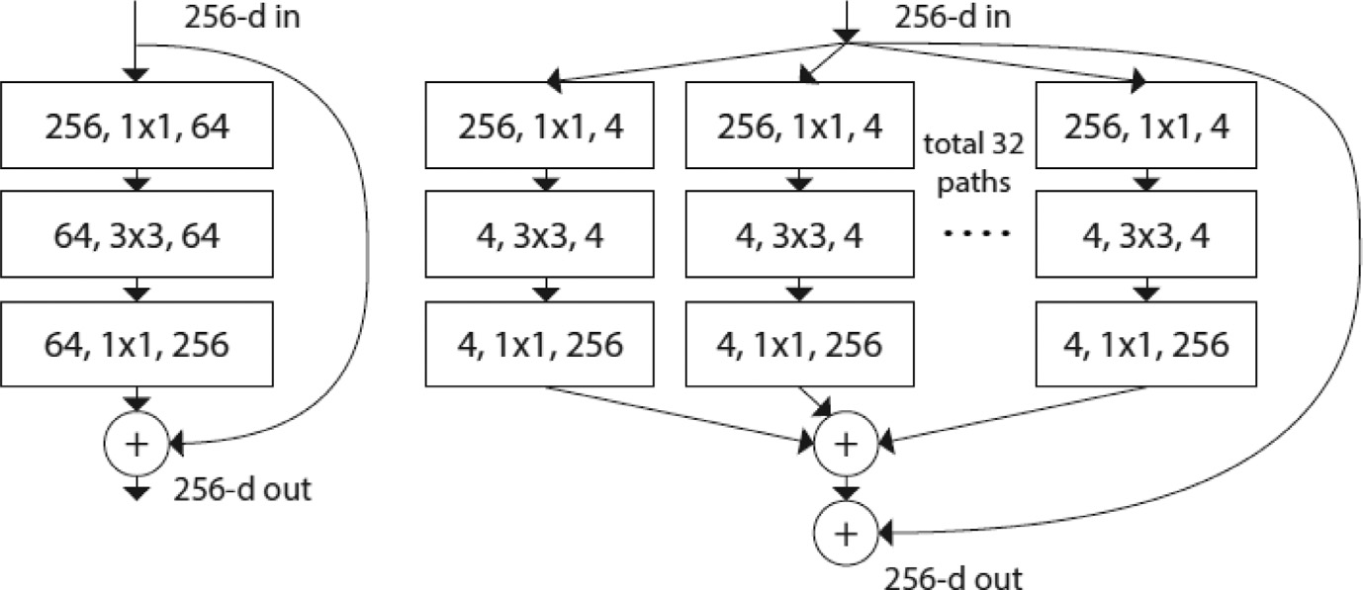

**Fig.4.**ResNet[57]isshownontheleft.AResNeXt blockwithcardinality=32andnearlythesamecom-plexityasthepreviousblockisshownontheright.A layerisrepresentedas(numberofinchannels,filtersize, numberofoutchannels).

|  |  |
| --- | --- |
| volumeswhileusingthesameresource.InductivebiasesinCoAtNetal-lowittogeneralizelikeConvNets.Inaddition,CoAtNetbenefitsfrom bettertransformerscalabilityandquickerconvergence,increasingits efficiency.  Generalizationandmodelcapacityarethetwomainelementsfrom whichhybridizingconvolutionandattentioninmachinelearningis | examined.Theresearchdemonstratesthatconvolutionallayershave greatergeneralizationwhileattentionhashighermodelcapacity.We cangetgreatergeneralizationandcapacitybymergingconvolutional andattentionlayers.  Thishybridmodelismorefocusedonimageclassificationandis basedontwokeyfeatures:(a)Depthwiseconvolutionandself-attention |

4

*S.Tripathi,A.I.Augustin,R.Sukumaranetal.*

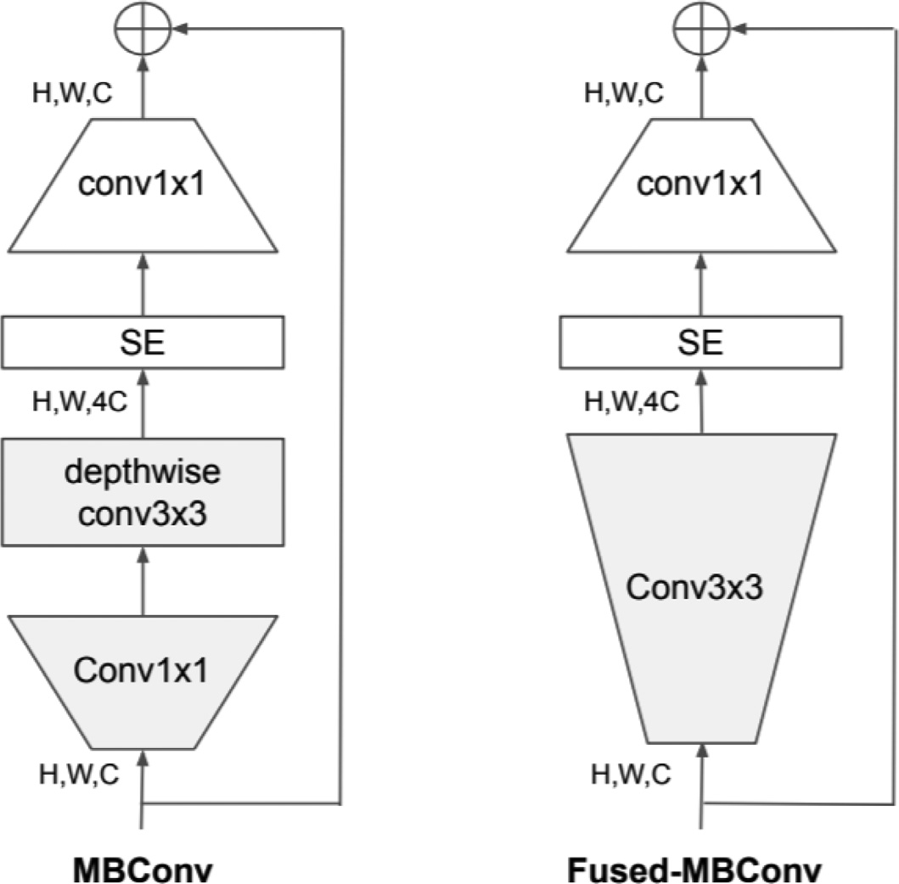

**Fig.5.**TheMBConvandFused-MBConvblocksareshowninthediagramabove.

|  |
| --- |
| mayreadilybecombinedusingsimplerelativeattention.(b)Bystacking convolutionlayersandattentionlayersinalogicalway,generalization, capacity,andefficiencyaregreatlyincreased.  Themodelarchitecture,showninFig.6,consistofconvolutionand self-attentionoperations.Theconvolutionallayerreducesthedimen-sionalityoftheinput.TheMBconvblocksareatypeofimageresidual blockthathasaninvertedstructure.ThefirstMBconvblockexpandsthe inputby4xbeforeperformingadepthwiseconvolutiontocapturethe spatialinteractionandthesecondblockwillcompressitbeforeaddinga residual.Depthwiseconvolutionperformsconvolutionforeachchannel separatelycanbeexpressedas:  *𝑦𝑖*= *𝑗*∈(*𝑖*)∑*𝑤𝑖*−*𝑗⊙ 𝑥𝑗*  (4)  where*𝑥𝑖,𝑦𝑖*∈ ℝ*𝐷*aretheinputandoutputatposition*𝑖*respectively, and(*𝑖*)denotesalocalneighborhoodof*𝑖*,e.g.,a3× 3gridcenteredat *𝑖*inimageprocessing.Fortheself-attentionblocksandfeed-forward network(FNN)moduleusesthesameexpansion-compressionstruc-ture,similartotheMBConvblocks.Incomparison,self-attentionallows thereceptivefieldtobetheentirespatiallocationsandcomputesthe weightsbasedonthere-normalizedpairwisesimilaritybetweenthepair (*𝑥𝑖,𝑥𝑗*  *𝑦𝑖*=∑ ) ∶2  *⏟⏞⏞⏞⏞⏞⏞⏞⏞⏞⏞⏟⏞⏞⏞⏞⏞⏞⏞⏞⏞⏞⏟*∑*𝑘*∈exp(*𝑥⊤*exp(*𝑥⊤*  *𝐴𝑖,𝑗*   *𝑖𝑥𝑗*  *𝑖𝑥𝑘* ) ) *𝑥𝑗*  (5)  whereindicatestheglobalspatialspace.Thelastthreestagesofa CoAtNetcanbeeitheraConvolutionoraTransformerblock,resulting inmultiplecombinationsforthemodelarchitecture.Table1displays thefamilyofCoAtNetmodelsthathavedifferentsizes,numberofblocks andhiddenchannelsinthemodelarchitecture.  Input-AdaptiveWeightingmakesself-attentionmorepronetocap-turetherelationshipsbetweendifferentelementsintheinputandGlobal ReceptiveFieldisthelargerreceptivefieldthat’susedinselfattention. AnoptimalmodelarchitectureinvolvesInput-AdaptiveWeightingand GlobalReceptiveFieldcharacteristicsofself-attentionandtheTransla-tionEquivariancethatisfeaturedinCNNsasawaytoimprovegener-alizationforalimitedsizedataset.Theoverallideaistosumaglobal |

5

*S.Tripathi,A.I.Augustin,R.Sukumaranetal.*  *ArtificialIntelligenceintheLifeSciences2(2022)100043*

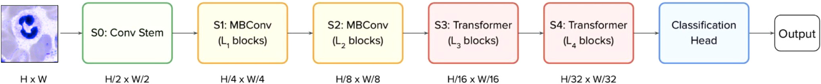

**Fig.6.**TheCoAtNetarchitectureisshowninthefigure.AninputpictureofsizeHxW,weuseconvolutionsatthefirststemstage(S0)todecreasethesizetoH/2 xW/2,whichisthefinalsize.Witheachstep,thesizeoftheobjectcontinuestoshrink.ThenumberoflayersisdenotedbytheletterLn.Then,thefirsttwostages (S1andS2)mostlyuseMBConvbuildingpieces,whicharecomposedofdepthwiseconvolutionoperations.Thelasttwostages(S3andS4)aremostlycomprisedof Transformerblockswithahighdegreeofrelativeself-attention.IncontrasttotheprecedingTransformerblocksinViT,weemploypoolingbetweenstagesinthis block,whichiscomparabletotheFunnelTransformerblock.Wethenuseaclassificationheadtoprovidepredictions.

**Table1**   
Lspecifiesthenumberofblocks,andDdenotesthenumberofchannelsinthehiddendimension.Wealwaysutilizethekernelsize3forallConv andMBConvblocks,nomatterwhat.Following[22],weincreasethesizeofeachattentionheadinallTransformerblocksto32.Theexpansion ratefortheinvertedbottleneckisalways4,whiletheexpansion(shrink)ratefortheSEisalways0.25.Theinvertedbottleneckisalsoknown astheinvertedbottleneck.

|  |  |  |  |  |  |  |  |  |  |  |  |
| --- | --- | --- | --- | --- | --- | --- | --- | --- | --- | --- | --- |
| Stage | Size | CoAtNet-0 |  | CoAtNet-1 |  | CoAtNet-2 |  | CoAtNet-3 |  | CoAtNet-4 |  |
| S0-Conv  S1-MbConv S2-MBConv S3-TFMRel S4-TFMRel | 1/2  1/4  1/8  1/16  1/32 | L=2  L=2  L=3  L=5  L=2 | D=64  D=96  D=192 D=398 D=768 | L=2  L=2  L=6  L=14  L=2 | D=64  D=96  D=192 D=398 D=768 | L=2  L=2  L=6  L=14  L=2 | D=128  D=128  D=256  D=512  D=1024 | L=2  L=2  L=6  L=14  L=2 | D=192  D=192  D=348  D=768  D=1536 | L=2  L=2  L=12  L=28  L=2 | D=192  D=192  D=348  D=768  D=1536 |

**Table2**   
ComparisonofMulti-ClassClassificationMetricsResultsamongstVariousModelsUsed.TheC,R,andErepresentsCoAtNet[56],ResNexT50 [54,55],andEffcientNetV2[53]respectively.

|  |  |  |  |  |  |  |  |  |  |
| --- | --- | --- | --- | --- | --- | --- | --- | --- | --- |
| ClassName | Accuracy |  |  | Precision |  |  | Recall |  |  |
|  | C | R | E | C | R | E | C | R | E |
| Bandneutrophils  Segmentedneutrophils Lymphocytes  Monocytes  Eosinophils  Basophils  Metamyelocytes  Myelocytes  Promyelocytes  Blasts  Plasmacells  Proerythroblasts  Erythroblasts  Hairycells  Abnormaleosinophils Immaturelymphocytes Faggotcells | **0.96**  **0.97**  0**.91**  **0.77**  **0.85**  **0.64**  **0.88**  **0.85**  **0.97**  **0.96**  **0.94**  **0.84**  **0.98**  **0.93**  **0.43**  **0.63**  **0.77** | 0.89  0.91  0.82  0.59  0.68  0.27  0.21  0.75  0.89  0.91  0.89  0.68  0.87  0.51  0.18  0.22  0.23 | 0.85  0.89  0.81  0.47  0.64  0.14  0.29  0.72  0.86  0.92  0.87  0.57  0.88  0.45  0.12  0.16  0.19 | **0.97**  **0.95**  **0.94**  **0.81**  **0.91**  **0.74**  **0.91**  **0.88**  **0.98**  **0.94**  **0.93**  **0.89**  **0.99**  **0.92**  **0.42**  **0.65**  **0.83** | 0.84  0.89  0.83  0.62  0.65  0.11  0.15  0.65  0.79  0.71  0.74  0.53  0.78  0.46  0.11  0.13  0.16 | 0.78  0.86  0.84  0.56  0.62  0.15  0.21  0.69  0.8  0.84  0.85  0.58  0.86  0.4  0.09  0.15  0.1 | **0.96**  **0.97**  **0.93**  **0.79**  **0.88**  **0.7**  **0.89**  **0.87**  **0.98**  **0.98**  **0.95**  **0.85**  **0.98**  **0.88**  **0.39**  **0.66**  **0.87** | 0.87  0.85  0.78  0.63  0.69  0.17  0.12  0.59  0.73  0.88  0.75  0.5  0.76  0.41  0.13  0.12  0.18 | 0.75  0.88  0.81  0.57  0.6  0.15  0.24  0.66  0.78  0.8  0.82  0.55  0.83  0.42  0.14  0.16  0.11 |

themorphologicalcategorization.Inthecaseofsegmentedneutrophils andbandneutrophils,whicharesubsequentmorphologicalclassesin theongoingprocessofmyelopoiesis,misunderstandingbetweenthetwo mightbedeemedtoleratedincertaincircumstances[59].

AsshowninTable2,theaccuracy,precision,andrecallvalues achievedbytheCoAtNet(C),ResNext2(R),andEfficientNetV2(E)for eachofthedistinctmorphologicalclasses.TheCoAtNetmodeloutper-formedbothoftheothermodelsbecauseofitsattentionnetworkprop-ertythatincreasedthelearningcurveforthealgorithmwhichisrepre-sentedusingaprecision-recallcurveinFig.7.

Forclassesinwhichtherearejustafewtrainingsamplesavailable, suchasfaggotcellsordiseasedeosinophils,theclassifierperformsless well,aswouldbeanticipatedforadata-drivenstrategy[60,61].There wouldbeagreaterneedfortrainingdataiftheimage-classificationjob wasfocusedonthedetectionoftheseparticularcelltypes.Itisalsopos-siblethattrainingabinaryclassifierratherthanacompletemulticlass classifierwillresultinimprovedpredictionperformance.Thefalseposi-tiveandfalsenegativecasesdepictsthesimilaritybetweeneachofthese cellsandthisre-enforcingtheimportanceaswellasthecomplexityof thetaskofclassificationofcellmorphology.

6

*S.Tripathi,A.I.Augustin,R.Sukumaranetal.*

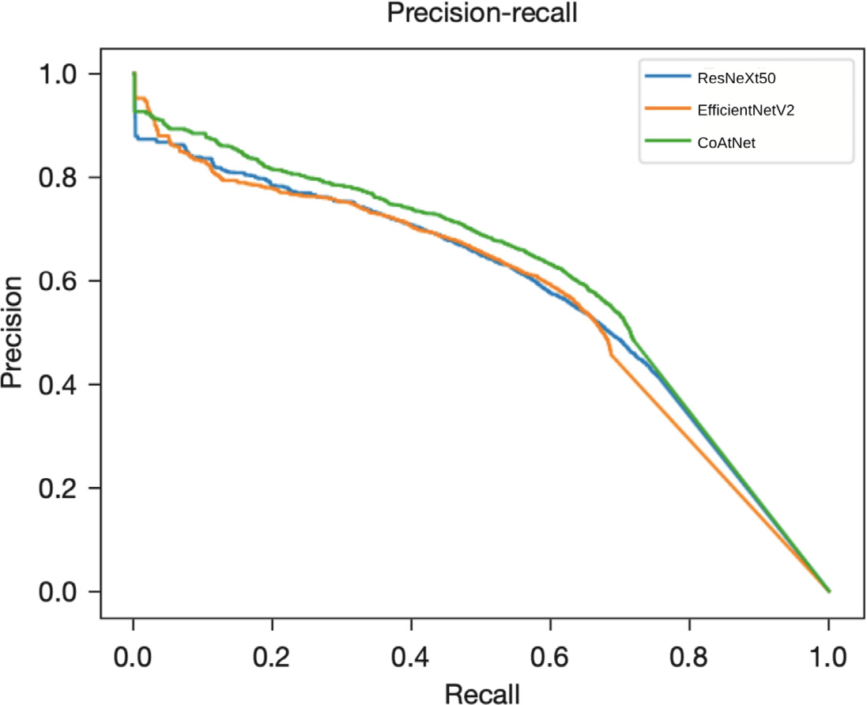

*ArtificialIntelligenceintheLifeSciences2(2022)100043*

**Fig.7.**Thefigureshowsprecision-recallcurveforeachofthemodelswe trained.theThetradeoff betweenprecisionandrecallmaybeseeninthe precision-recallcurveforvariousthresholdvalues.Alowfalsenegativeand falsepositiverateisassociatedwithahigherareaunderthecurve.

|  |  |
| --- | --- |
|  | **Fig.8.**Originalphotosclassifiedproperlyby thenetworkarepresentedinthetoprow. AllcellswerestainedwiththeMay-Gruenwald-Giemsa/Pappenheimstainandphotographedat 340magnification,asdescribedintheprimarytext. ThecenterrowdisplaysanalysisusingtheSmooth-Gradalgorithm.Thebrighterapixellooks,the moreitcontributestothecategorizationjudgment madebythenetwork.Resultsofasecondnetwork analysisapproach,theGrad-CAMalgorithm,are exhibitedinthebottomrowasaheatmapsu-perimposedontheoriginalpicture.Theareasof theimagethatcontainessentialinformationare highlightedinred.Bothanalyticalapproachesim-plythatthenetworkhastrainedtoconcentrateon theleukocytewhiledisregardingbackgroundstruc-ture.Notethenetwork’sfocusontraitsknowntobe significantforcertaincelltypes,suchasthecyto-plasmicorganizationofeosinophilsorthenuclear architectureofplasmacells. |

pattern.Althoughtheseanalyses,whenusedaspostclassificationex-planations,donotinandofthemselvesguaranteethecorrectnessofa particularclassificationdecision,theycanhelptoincreaseconfidence thatthenetworkhaslearnedtofocusonrelevantfeaturesofthesingle-cellimagesandthatpredictionsarebasedonreasonablecharacteristics. Asawhole,theresultsarepositiveandpromising,withgoodaccu-racyandrecallvaluesachievedforthevastmajorityofdiagnostically relevantclassesstudied.Ourresultsareconsistentwithpreviousfind-ingsinotherareasofmedicalimaging,whereattention-basedimage classificationtaskshaveoutperformedapproachesthatrelyontheex-tractionofimagefeaturestoattainhigherstandards[66–69].Themost importantcomponentofthesuccessfuluseofCNNsisatrainingdata setthatissufficientlybigandofgoodquality[70].

**5.Conclusion**

Aspartofthecurrentinvestigation,wemostlyusedasingle-center strategy,withallBMsmearsincludedfortraininghavingbeenstained, captured,andprocessedinthesamelaboratory.Thenetworkpresented

7

*S.Tripathi,A.I.Augustin,R.Sukumaranetal.*

formanceofournetworkinareal-worlddiagnosticenvironmentwill needmoreinvestigation.Therangeofdiagnosticmodalitiesemployed inhematologysuggeststhattheintegrationofsupplementarydata(for example,fromflowcytometryormoleculargenetics)wouldimprove thequalityofpredictionsmadebyneuralnetworks.

**DeclarationofCompetingInterest**

Theauthorsdeclarethattheyhavenoknowncompetingfinancial interestsorpersonalrelationshipsthatcouldhaveappearedtoinfluence theworkreportedinthispaper.

**References**

[[1]WintrobeMM.Clinicalhematology.AcadMed1962;37(1):78.](http://refhub.elsevier.com/S2667-3185(22)00013-7/sbref0002)

[[2]ThemlH,DiemH,HaferlachT.Coloratlasofhematology:practicalmicroscopicand](http://refhub.elsevier.com/S2667-3185(22)00013-7/sbref0002)  [clinicaldiagnosis.Thieme;2004.](http://refhub.elsevier.com/S2667-3185(22)00013-7/sbref0002)

[[3]Hoffma](http://refhub.elsevier.com/S2667-3185(22)00013-7/sbref0002)n[R,BenzJrEJ,SilbersteinLE,HeslopH,AnastasiJ,WeitzJ.Hematology:](http://refhub.elsevier.com/S2667-3185(22)00013-7/sbref0002)  [basicprinciplesandpractice.ElsevierHealthSciences;2013.](http://refhub.elsevier.com/S2667-3185(22)00013-7/sbref0003)

[[4]Löffl](http://refhub.elsevier.com/S2667-3185(22)00013-7/sbref0003)er[H,RastetterJ.Atlasofclinicalhematology.SpringerScience&BusinessMe-](http://refhub.elsevier.com/S2667-3185(22)00013-7/sbref0003) [dia;2012.](http://refhub.elsevier.com/S2667-3185(22)00013-7/sbref0004)

[[5]KratzA,LeeS-h,ZiniG,RiedlJA,HurM,MachinS,etal.Digitalmorphol-](http://refhub.elsevier.com/S2667-3185(22)00013-7/sbref0004)[ogyanalyzersinhematology:ICSHreviewandrecommendations.Int.JLabHematol 2019;41(4):437–47.](http://refhub.elsevier.com/S2667-3185(22)00013-7/sbref0005)

[[6]SalakijC,SalakijJ,ApibalS,NarkkongN-A,ChanhomeL,RochanapatN.Hematol-](http://refhub.elsevier.com/S2667-3185(22)00013-7/sbref0005)[ogy,morphology,cytochemicalstaining,andultrastructuralcharacteristicsofblood cellsinkingcobras(ophiophagushannah).VetClinPathol2002;31(3):116–26.](http://refhub.elsevier.com/S2667-3185(22)00013-7/sbref0006)

[[7]ThomasX.Firstcontributorsinthehistoryofleukemia.WorldJHaematol](http://refhub.elsevier.com/S2667-3185(22)00013-7/sbref0006)  [2013;2(62).](http://refhub.elsevier.com/S2667-3185(22)00013-7/sbref0008)

[[8]TkachukD,HirschmannJ.Approachtothemicroscopicevaluationofbloodand bonemarrow.WintrobeAtlasClinHaematolLippincottWilliamsWilkins2007.](http://refhub.elsevier.com/S2667-3185(22)00013-7/sbref0008)

[[9]BriggsC,LongairI,SlavikM,ThwaiteK,MillsR,ThavarajaV,etal.Canautomated](http://refhub.elsevier.com/S2667-3185(22)00013-7/sbref0008) [bloodfilmanalysisreplacethemanualdifferential?Anevaluationofthecellavision dm96automatedimageanalysissystem.IntJLabHematol2009;31(1):48–60.](http://refhub.elsevier.com/S2667-3185(22)00013-7/sbref0009)

[[10]AnguloJ,FlandrinG.Automateddetectionofworkingareaofperipheralblood](http://refhub.elsevier.com/S2667-3185(22)00013-7/sbref0009)  [smearsusingmathematicalmorphology.AnalCellPathol2003;25(1):37–49.](http://refhub.elsevier.com/S2667-3185(22)00013-7/sbref0011)

[[11]MatekC,SchwarzS,SpiekermannK,MarrC.Human-levelrecognitionofblastcells inacutemyeloidleukaemiawithconvolutionalneuralnetworks.NatMachIntell 2019;1(11):538–44.](http://refhub.elsevier.com/S2667-3185(22)00013-7/sbref0011)

[[12]NabityMB,HarrKE,CamusMS,FlatlandB,VapLM.ASVCPguidelines:allowable](http://refhub.elsevier.com/S2667-3185(22)00013-7/sbref0011)  [totalerrorhematology.VetClinPathol2018;47(1):9–21.](http://refhub.elsevier.com/S2667-3185(22)00013-7/sbref0012)

[[13]SimonsA,Sikkema-RaddatzB,deLeeuwN,KonradNC,HastingsRJ,SchoumansJ.](http://refhub.elsevier.com/S2667-3185(22)00013-7/sbref0012)

[Genome-widearraysinroutinediagnosticsofhematologicalmalignancies.HumMut 2012;33(6):941–8.](http://refhub.elsevier.com/S2667-3185(22)00013-7/sbref0013)

[[14]Fuentes-ArderiuX,Dot-BachD.Measurementuncertaintyinmanualdifferentia](http://refhub.elsevier.com/S2667-3185(22)00013-7/sbref0013)l [leukocytecounting.ClinChemLabMed2009;47(1):112–15.](http://refhub.elsevier.com/S2667-3185(22)00013-7/sbref0014)

[[15]FontP,LoscertalesJ,SotoC,RicardP,NovasCM,Martín-ClaveroE,etal.Inter-](http://refhub.elsevier.com/S2667-3185(22)00013-7/sbref0014)[observervarianceinmyelodysplasticsyndromeswithlessthan5%bonemarrow blasts:unilineagevs.multilineagedysplasiaandreproducibilityofthethresholdof 2%blasts.AnnHematol2015;94(4):565–73.](http://refhub.elsevier.com/S2667-3185(22)00013-7/sbref0015)

[[16]KrappeS,BenzM,WittenbergT,HaferlachT,MünzenmayerC.Automatedclassi-](http://refhub.elsevier.com/S2667-3185(22)00013-7/sbref0015)[ficationofbonemarrowcellsinmicroscopicimagesfordiagnosisofleukemia:a comparisonoftwoclassificationschemeswithrespecttothesegmentationquality.](http://refhub.elsevier.com/S2667-3185(22)00013-7/sbref0016)

[Medicalimaging2015:computer-aideddiagnosis,9414.InternationalSocietyfor OpticsandPhotonics;2015.94143I.](http://refhub.elsevier.com/S2667-3185(22)00013-7/sbref0016)

[[17]RetaC,AltamiranoL,GonzalezJA,Diaz-HernandezR,PeregrinaH,OlmosI,etal.](http://refhub.elsevier.com/S2667-3185(22)00013-7/sbref0016)

[Segmentationandclassificationofbonemarrowcellsimagesusingcontextualinfor-mationformedicaldiagnosisofacuteLeukemias.PLoSOne2015;10(6):e0130805. [18]ChandradevanR,AljudiAA,DrumhellerBR,KunananthaseelanN,AmgadM,Gut-](http://refhub.elsevier.com/S2667-3185(22)00013-7/sbref0017)[manDA,etal.Machine-baseddetectionandclassificationforbonemarrowaspirate differentialcounts:initialdevelopmentfocusingonnonneoplasticcells.LabInvestig 2020;100(1):98–109.](http://refhub.elsevier.com/S2667-3185(22)00013-7/sbref0018)

[[19]SongT-H,SanchezV,DalyHE,RajpootNM.Simultaneouscelldetectionand](http://refhub.elsevier.com/S2667-3185(22)00013-7/sbref0018) [classificationinbonemarrowhistologyimages.IEEEJBiomedHealthInform 2018;23(4):1469–76.](http://refhub.elsevier.com/S2667-3185(22)00013-7/sbref0019)

[[20]KrappeS,WittenbergT,HaferlachT,MünzenmayerC.Automatedmorphological](http://refhub.elsevier.com/S2667-3185(22)00013-7/sbref0019) [analysisofbonemarrowcellsinmicroscopicimagesfordiagnosisofleukemia: nucleus-plasmaseparationandcellclassificationusingahierarchicaltreemodel ofhematopoesis.Medicalimaging2016:computer-aideddiagnosis,9785.Interna-tionalSocietyforOpticsandPhotonics;2016.97853C.](http://refhub.elsevier.com/S2667-3185(22)00013-7/sbref0020)

[[21]ScottiF.Automaticmorphologicalanalysisforacuteleukemiaidentificatio](http://refhub.elsevier.com/S2667-3185(22)00013-7/sbref0020)n[inpe-](http://refhub.elsevier.com/S2667-3185(22)00013-7/sbref0020)[ripheralbloodmicroscopeimages.In:CIMSA.2005IEEEinternationalconferenceon computationalintelligenceformeasurementsystemsandapplications,2005..IEEE; 2005.p.96–101.](http://refhub.elsevier.com/S2667-3185(22)00013-7/sbref0021)

[[22]KimuraK,TabeY,AiT,TakeharaI,FukudaH,TakahashiH,etal.Anovelauto-](http://refhub.elsevier.com/S2667-3185(22)00013-7/sbref0021)[matedimageanalysissystemusingdeepconvolutionalneuralnetworkscanassistto differentiateMDSandAA.SciRep2019;9(1):1–9.](http://refhub.elsevier.com/S2667-3185(22)00013-7/sbref0022)

[[23]MoriJ,KajiS,KawaiH,KidaS,TsubokuraM,FukatsuM,etal.Assessment](http://refhub.elsevier.com/S2667-3185(22)00013-7/sbref0022) [ofdysplasiainbonemarrowsmearwithconvolutionalneuralnetwork.SciRep](http://refhub.elsevier.com/S2667-3185(22)00013-7/sbref0023) [2020;10(1):1–8.](http://refhub.elsevier.com/S2667-3185(22)00013-7/sbref0024)

[[24]WuY-Y,HuangT-C,YeR-H,FangW-H,LaiS-W,ChangP-Y,etal.Ahematolo-gist-leveldeeplearningalgorithm(bmsnet)forassessingthemorphologiesofsin-](http://refhub.elsevier.com/S2667-3185(22)00013-7/sbref0024)

8

*S.Tripathi,A.I.Augustin,R.Sukumaranetal.*

[[55]RussakovskyO,DengJ,SuH,KrauseJ,SatheeshS,MaS,etal.Imagenetlargescale](http://refhub.elsevier.com/S2667-3185(22)00013-7/sbref0055)  [visualrecognitionchallenge.IntJComputVis2015;115(3):211–52.](http://refhub.elsevier.com/S2667-3185(22)00013-7/sbref0056)

[[56]DaiZ,LiuH,LeQV,TanM.Coatnet:marryingconvolutionandattentionforalldata](http://refhub.elsevier.com/S2667-3185(22)00013-7/sbref0056)  [sizes.AdvNeuralInfProcessSyst2021;34:3965–77.](http://refhub.elsevier.com/S2667-3185(22)00013-7/sbref0056)

[[57]HeK,ZhangX,RenS,SunJ.Deepresiduallearningforimagerecognition.In:Pro-](http://refhub.elsevier.com/S2667-3185(22)00013-7/sbref0056)[ceedingsoftheIEEEconferenceoncomputervisionandpatternrecognition;2016. p.770–8.](http://refhub.elsevier.com/S2667-3185(22)00013-7/sbref0057)

[[58]DoanM,SebastianJA,CaicedoJC,SiegertS,RochA,TurnerTR,etal.Ob-](http://refhub.elsevier.com/S2667-3185(22)00013-7/sbref0057)[jectiveassessmentofstoredbloodqualitybydeeplearning.ProcNatlAcadSci](http://refhub.elsevier.com/S2667-3185(22)00013-7/sbref0058) [2020;117(35):21381–90.](http://refhub.elsevier.com/S2667-3185(22)00013-7/sbref0059)

[[59]KrappeS,WittenbergT,HaferlachT,MünzenmayerC.Automatedmorphological analysisofbonemarrowcellsinmicroscopicimagesfordiagnosisofleukemia: nucleus-plasmaseparationandcellclassificationusingahierarchicaltreemodel ofhematopoesis.Medicalimaging2016:computer-aideddiagnosis,9785.Interna-tionalSocietyforOpticsandPhotonics;2016.97853C.](http://refhub.elsevier.com/S2667-3185(22)00013-7/sbref0059)

[[60]RawatW,WangZ.Deepconvolutionalneuralnetworksforimageclassification](http://refhub.elsevier.com/S2667-3185(22)00013-7/sbref0059):[a](http://refhub.elsevier.com/S2667-3185(22)00013-7/sbref0059)  [comprehensivereview.NeuralComput2017;29(9):2352–449.](http://refhub.elsevier.com/S2667-3185(22)00013-7/sbref0061)

[[61]SchoutenJP,MatekC,JacobsLF,BuckMC,BošnačkiD,MarrC.Tensofimages cansufficetotrainneuralnetworksformalignantleukocytedetection.SciRep 2021;11(1):1–8.](http://refhub.elsevier.com/S2667-3185(22)00013-7/sbref0061)

9